Lab 15 – Backend API Development: Creating RESTful services
with AI

Sriramoju vishnu vardhana chary
2503A51279
Batch - 44

Lab Objectives:
• Understand the fundamentals of RESTful API design.
• Use AI-assisted coding tools to generate backend services.
• Implement CRUD (Create, Read, Update, Delete) operations.
• Document endpoints with comments and auto-generated
documentation.

Task Descriptor-1: (Setup Fast API Backend )
Instructions:
• Install Fas tAPI and Uvicorn.
• Use AI to generate a basic FastAPI application with one endpoint

Sample Code:
from fastapi import FastAPI
app = FastAPI()
@app.get(&quot;/&quot;)
def read_root():
return {&quot;message&quot;: &quot;Welcome to AI-powered FastAPI&quot;}
Expected Output:
Running the server and accessing:
http://127.0.0.1:8000/
Response:
{&quot;message&quot;: &quot;Welcome to AI-powered FastAPI&quot;}

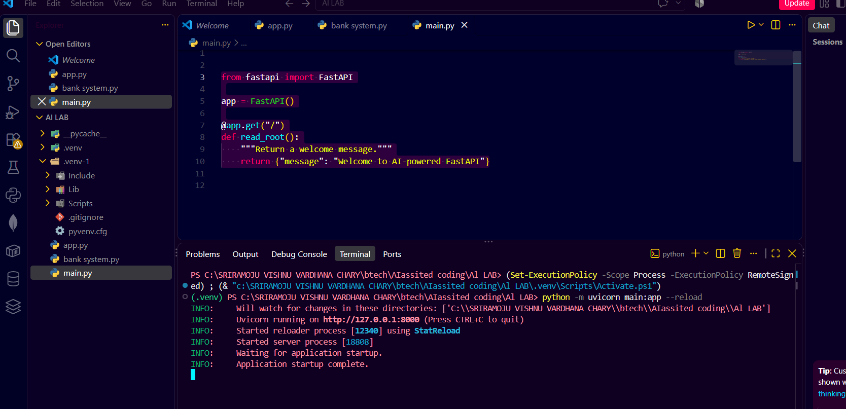

Task Descriptor- 2: (API – Create and Read Items)
Instructions:
• Implement endpoints to add and retrieve products.
• Use a Python list as temporary storage.

Sample Code:
items = []
@app.get(&quot;/items&quot;)
def get_items():
return items
@app.post(&quot;/items&quot;)
def add_item(item: dict):
items.append(item)
return {&quot;message&quot;: &quot;Item created&quot;, &quot;item&quot;: item}
Expected Output:
GET /items → []
POST /items with {&quot;name&quot;:&quot;Pen&quot;,&quot;price&quot;:20}
→ {&quot;message&quot;:&quot;Item created&quot;,&quot;item&quot;:{&quot;name&quot;:&quot;Pen&quot;,&quot;price&quot;:20}}

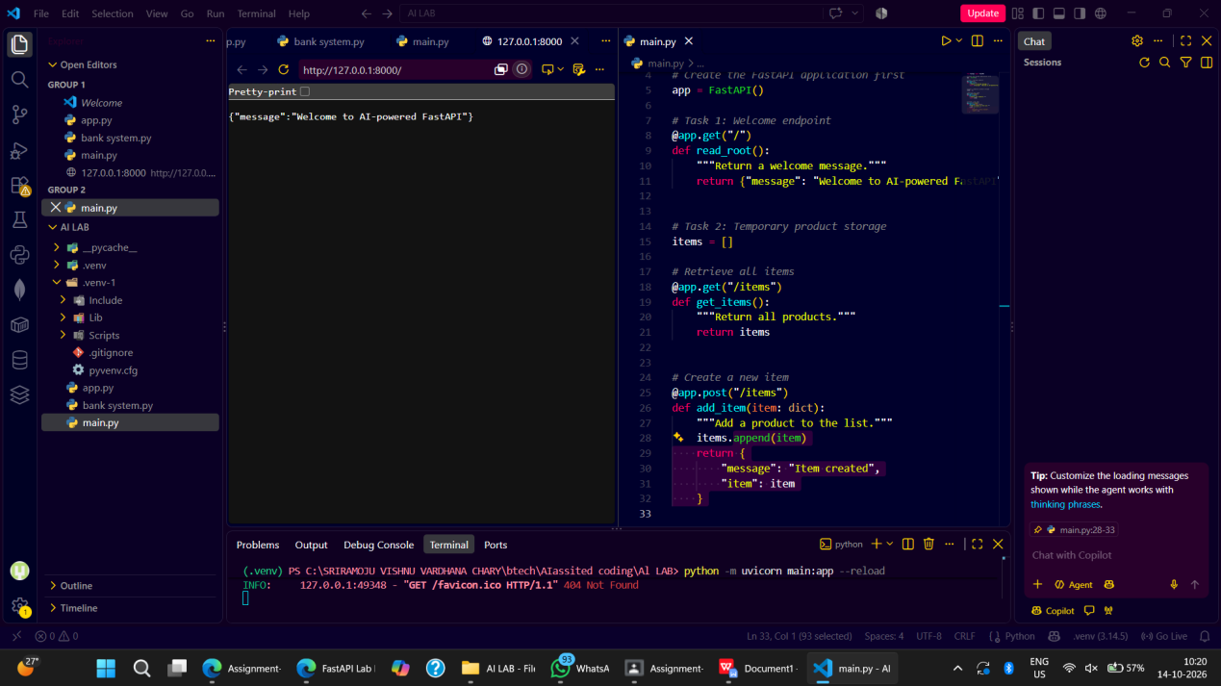

Task Descriptor- 3: (Update Existing Item)
Instructions:
• Use AI to generate an endpoint to update an item using its index.

Task Descriptor- 4: (Delete Item)
Instructions:
• Implement deletion of an item by index.
Sample Code:
@app.delete(&quot;/items/{index}&quot;)
def delete_item(index: int):
if index &gt;= len(items):
return {&quot;error&quot;: &quot;Item not found&quot;}
removed = items.pop(index)
return {&quot;message&quot;: &quot;Item removed&quot;, &quot;item&quot;: removed}
Expected Output:
DELETE /items/0
→ {&quot;message&quot;:&quot;Item removed&quot;,&quot;item&quot;:{&quot;name&quot;:&quot;Pencil&quot;,&quot;price&quot;:10}}

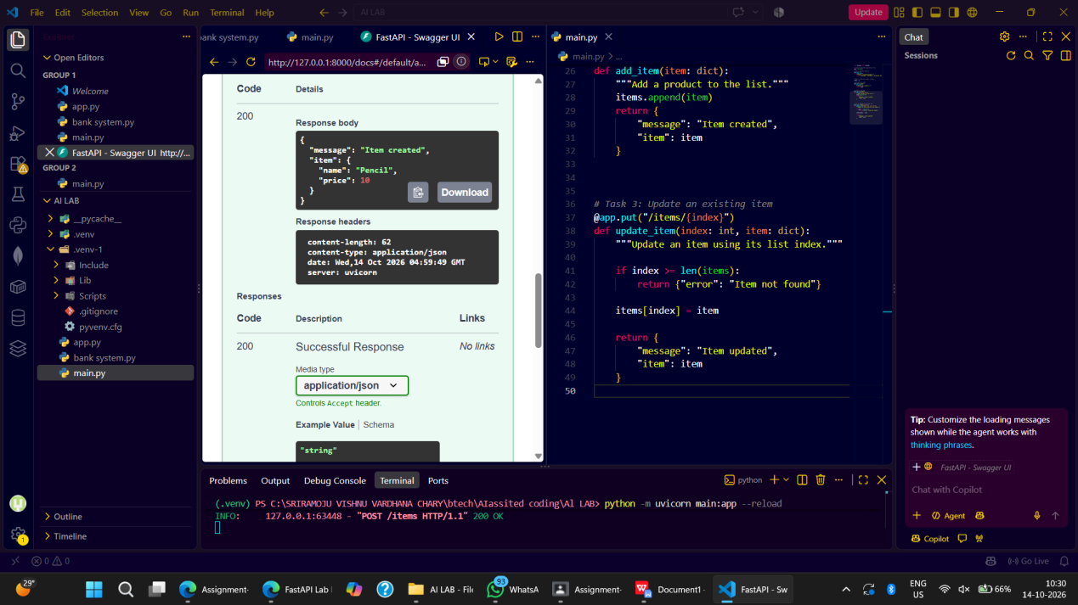

Task Descriptor -5: (Add Auto-Generated Documentation)
Instructions:
• Use AI to add inline comments and docstrings for all endpoints.
• Optionally, integrate Swagger / Flask-RESTX to auto-generate
API documentation.
Sample Code:
@app.route(&#39;/items&#39;, methods=[&#39;GET&#39;])
def get_items():
&quot;&quot;&quot;
GET /items
Returns a list of all items in the store.

